Name : Kasak Patel
Roll No : 05
Sec-Batch : B-b1
ML LAB 4
Aim : Implement the Decision Tree Classification algorithm on Dataset.
Theory:
. Overview of Decision Tree Algorithm
- A Decision Tree is a supervised machine learning algorithm used for both classification and regression tasks.
- It builds a model in the form of a tree structure, breaking down a dataset into smaller subsets while incrementally developing an associated decision tree.
- Tree Structure Components:
  - Root Node: Represents the entire dataset, which gets divided into two or more homogeneous sets.
  - Internal/Decision Nodes: Represent feature attribute tests where splits occur based on decision rules.
  - Leaf/Terminal Nodes: Represent final class predictions or outcomes and do not split further.
  - Branches: Represent the outcomes of tests/splits leading to subsequent nodes.
- Key Mathematical Metrics for Splitting
Decision trees select feature splits by evaluating impurity metrics to create pure internal nodes.
  - Entropy: Measures the degree of randomness, uncertainty, or impurity in a dataset. For a dataset with probabilities for each class , Entropy is given by:
    - An entropy of indicates a pure node (all samples belong to one class). o High entropy indicates an even distribution across multiple classes.
  - Information Gain: Measures the reduction in entropy achieved by partitioning data according to a specific feature attribute . The attribute with the highest Information Gain is chosen for the split:
  - Gini Impurity: An alternative splitting criterion measuring the probability of incorrectly classifying a randomly chosen element:
- Decision Tree Workflow & Implementation Steps
  - Data Preprocessing & Cleaning: Handle missing values, check distributions, and drop duplicate entries to avoid skewed decision rules.
  - Feature & Target Definition: Separate feature variables () from the target classification variable ().
  - Train-Test Splitting: Partition the dataset into training and testing sets (typically 80/20 ratio) using stratified sampling to maintain class proportions.
  - Model Training: Fit the decision tree classifier on training data using specified criteria (such as 'entropy').
  - Evaluation Metrics: Assess model accuracy, precision, recall, F1-score, confusion matrices, and ROC-AUC curves on test data to detect overfitting.
- Advantages & Disadvantages
  - Advantages: Easy to understand and interpret visual tree diagrams, handles numerical and categorical features well, requires minimal data preprocessing.
  - Disadvantages: Highly prone to overfitting (high training accuracy vs. lower testing accuracy) when trees grow too deep without max-depth restrictions or
  - hyperparameter tuning. Github link - https://github.com/GauriRaut58/Gauri-/blob/main/Lab_4_C_52_Gauri%20Raut.pdf
  - Python libraries:
    - Pandas – data loading and manipulation o NumPy – numerical operations o Matplotlib – data visualization
    - Seaborn – statistical visualization o Scikit-learn – Decision Tree model and evaluation metrics
Procedure:
  - Load the Wine Quality dataset using Pandas.
  - Display the first and last few records using head() and tail().
  - Check the dataset shape, descriptive statistics, data types, and missing values.
  - Check for duplicate records and remove duplicates.
  - Perform Univariate Analysis using histograms, KDE plots, boxplots, and quality distribution plots.
  - Perform Bivariate Analysis using boxplots and scatterplots to study relationships between wine properties and quality.
  - Perform Multivariate Analysis using a correlation heatmap and pair plot.
  - Divide wine quality into quality groups such as Low, Medium, and High for analysis.
  - Separate the dataset into features (X) and target variable (y).
10.Split the data into training and testing sets using an 80:20 ratio.
11.Create a Decision Tree Classifier using the Entropy criterion.
12.Train the Decision Tree model using the training data.
13.Predict wine quality for both training and testing data.
14.Evaluate the model using Accuracy, Precision, Recall, F1-score, and Confusion Matrix.
15.Visualize the Decision Tree and analyze its depth and number of leaves.
16.Plot the ROC-AUC curve to evaluate the classification performance.
17.Perform hyperparameter tuning to improve the Decision Tree model.
The practical specifically uses the Wine Quality dataset and a Decision Tree with criterion='entropy'.
The lab uses the Wine Quality dataset (red wine) with 1,599 rows and 12 features.
Features include: fixed acidity, volatile acidity, citric acid, residual sugar, chlorides, free sulfur dioxide, total sulfur dioxide, density, pH, sulphates, alcohol, and quality.
No missing values were found.
240 duplicate rows were removed, leaving 1,359 unique entries.
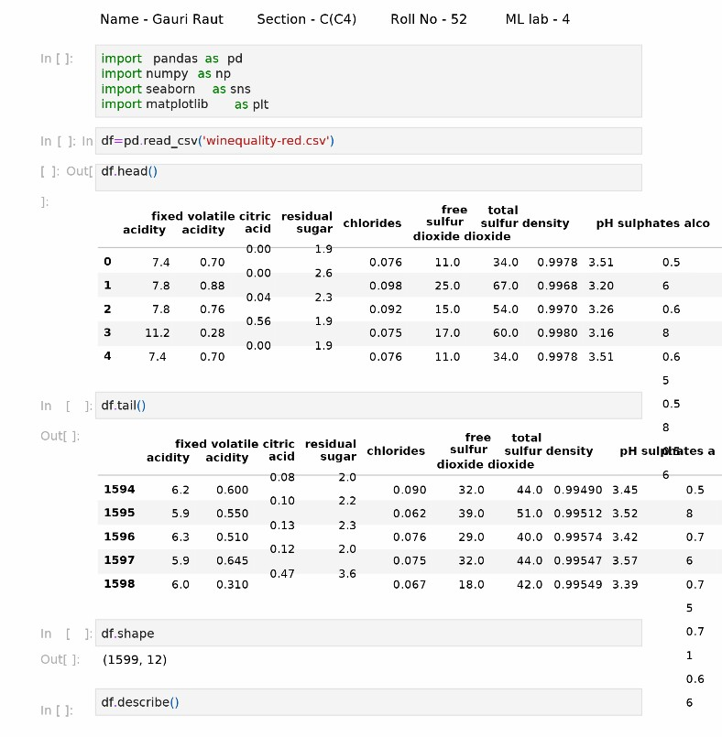
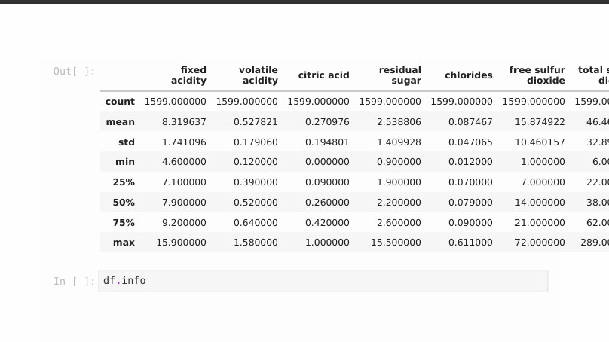
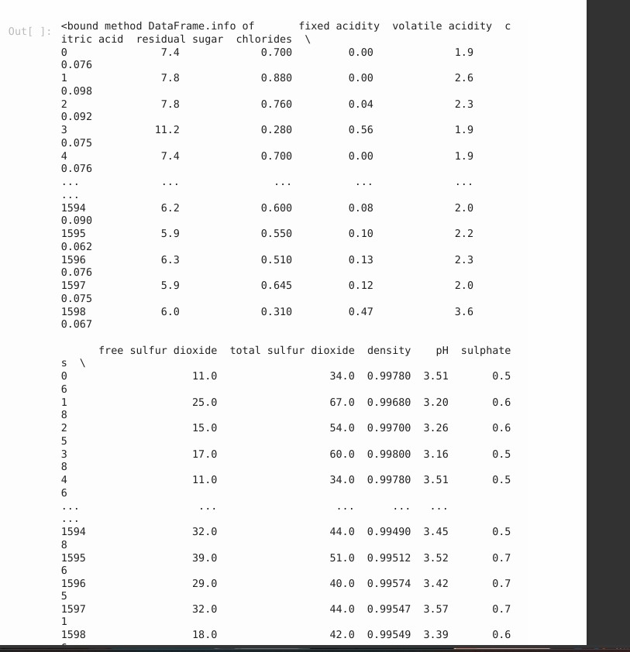
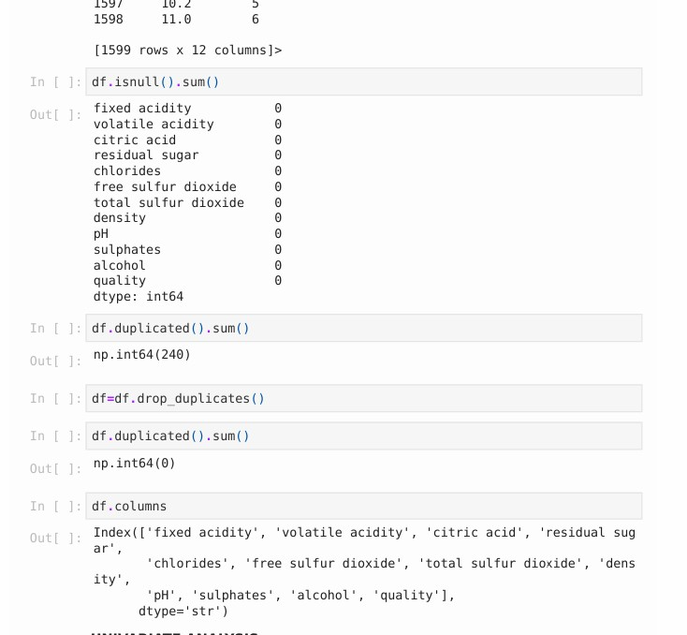
- definition: Statistical data analysis technique that evaluates a single variable in isolation without examining relationships with other variables.
- Core Objective: Summarizes, describes, and inspects the fundamental patterns, central values, and overall distribution of one dataset feature.
- Primary Summary Metrics:
  - Central Tendency: Mean, median, and mode.
  - Dispersion & Spread: Range, variance, standard deviation, and Interquartile Range (IQR).
  - Distribution Shape: Skewness (asymmetry) and kurtosis (tail weight).
- Common Visualizations: Histograms and Kernel Density Estimation (KDE)
plots (for continuous data distributions), box plots (for detecting outliers), and count plots/bar charts (for categorical frequencies).
•
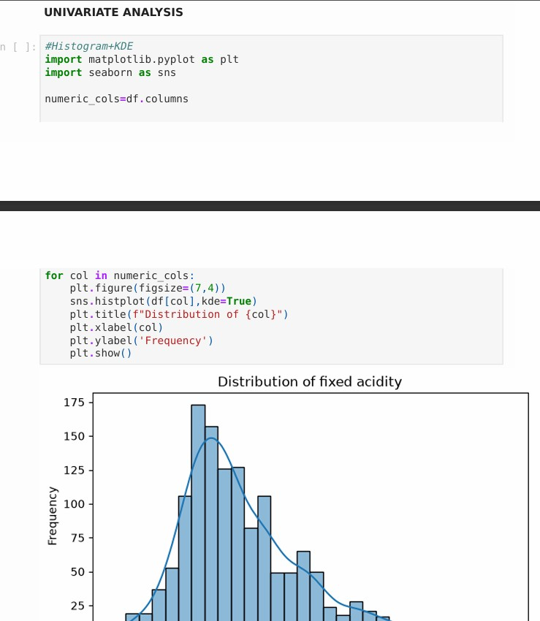
•
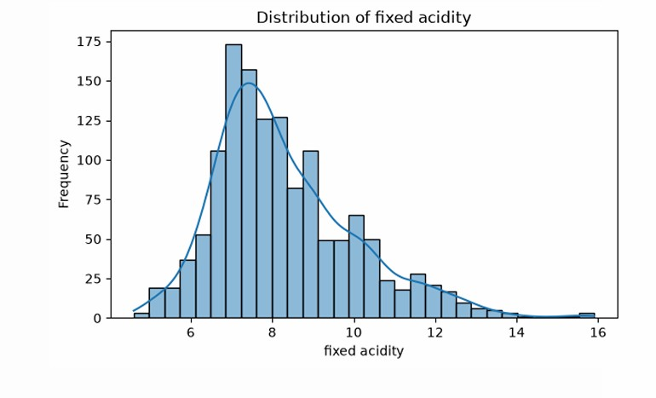
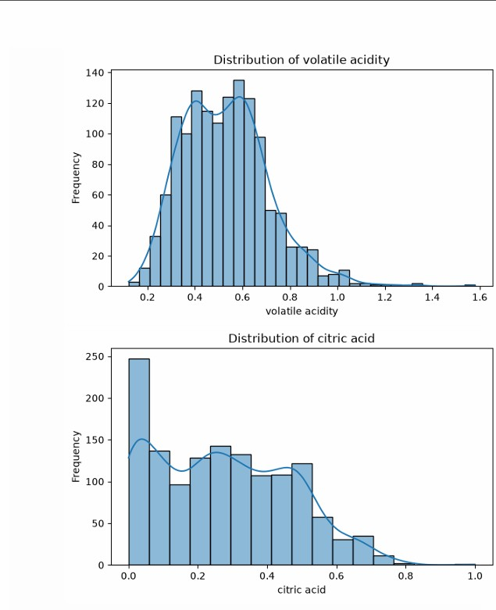
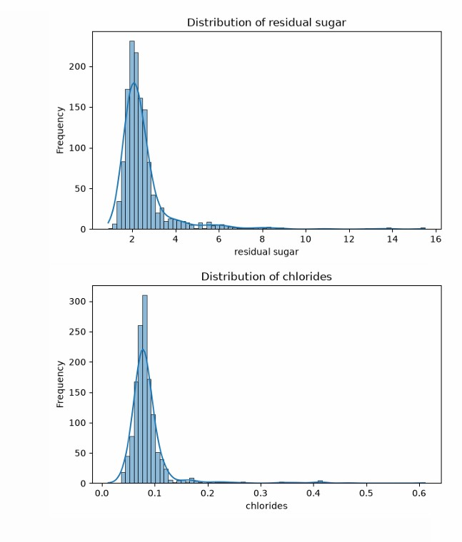
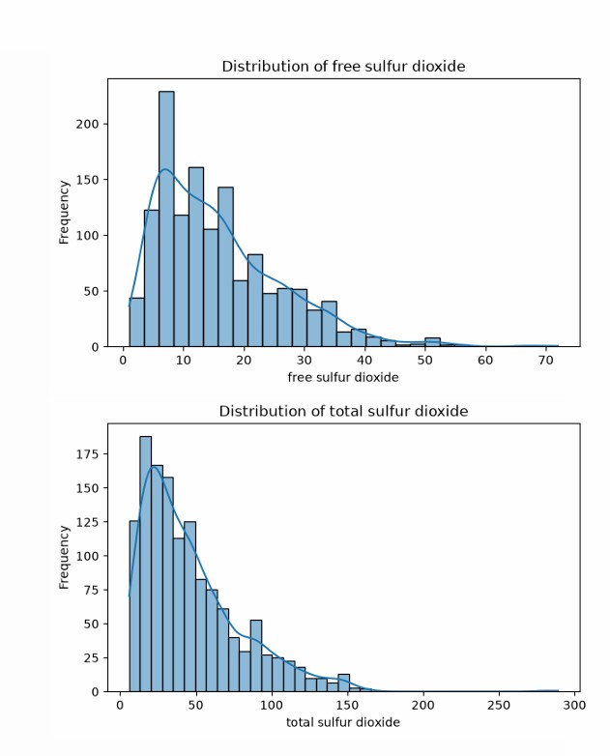
- • 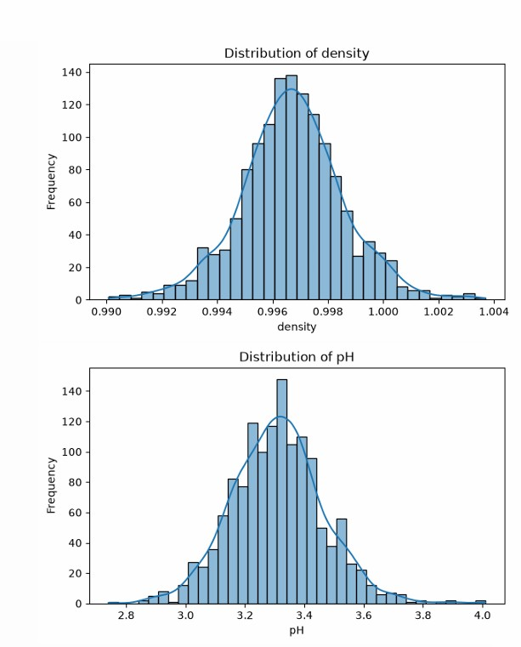• 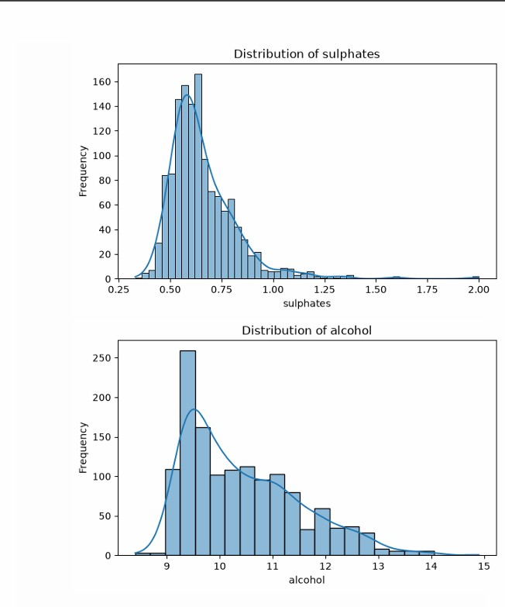• 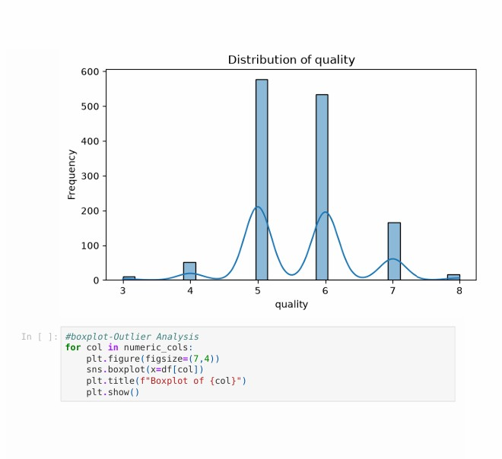

Boxplot Analysis
- Boxplots revealed the presence of several outliers, especially in features like residual sugar, chlorides, and sulphates.
- Most variables showed a fairly compact distribution, but alcohol and volatile acidity displayed wider spreads.
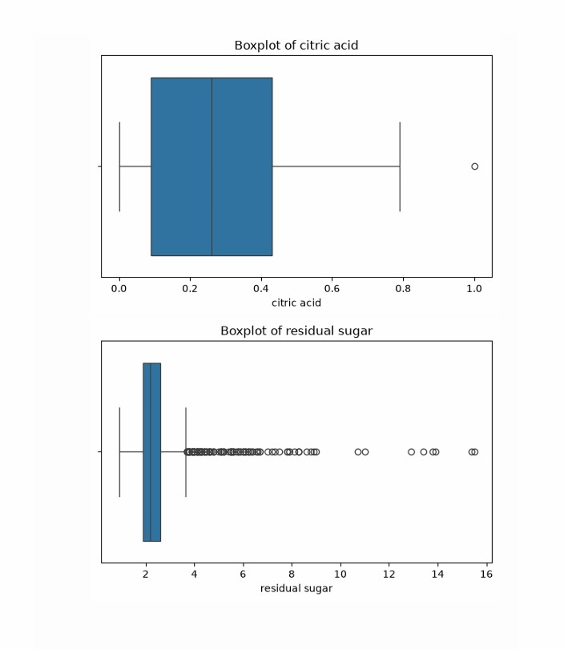
- Quality-related boxplots indicated that higher alcohol content tends to align with • better wine quality, while higher volatile acidity is linked to lower quality.
• 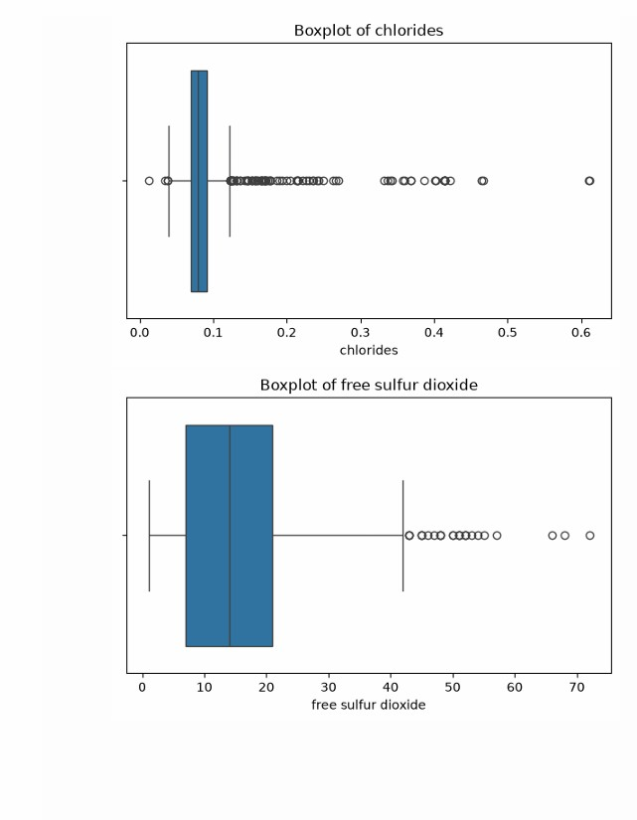
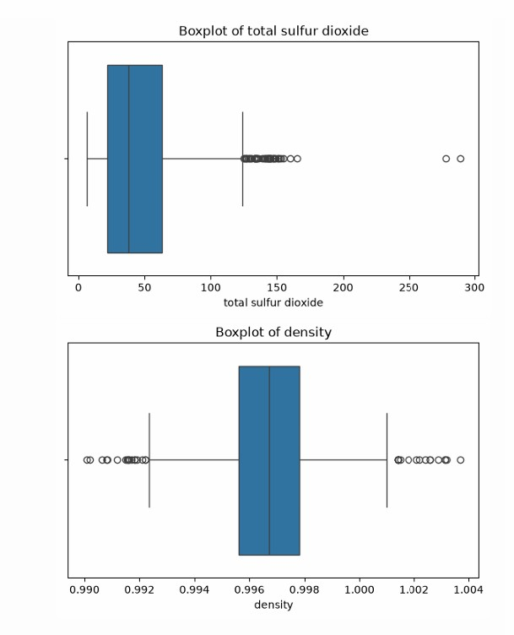
- 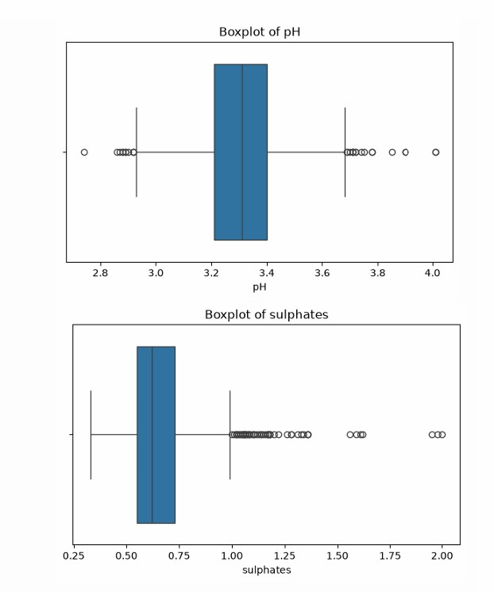• 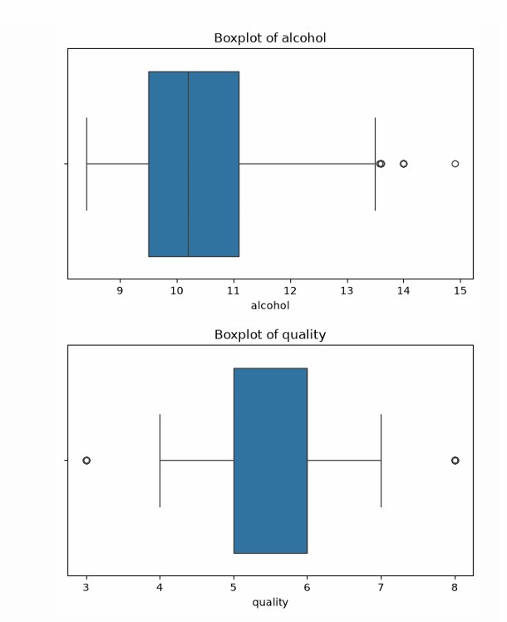
Quality Distribution
- The wine quality scores range mostly between 3 and 8, with no samples rated at the extremes (0–10).
- Majority of wines fall into the medium quality category, especially ratings of 5 and 6.
- Very few wines are rated as high quality (7–8), and lowquality wines (3–4) are also relatively rare.
- This imbalance suggests the dataset is skewed toward average wines, which can affect model performance.
- 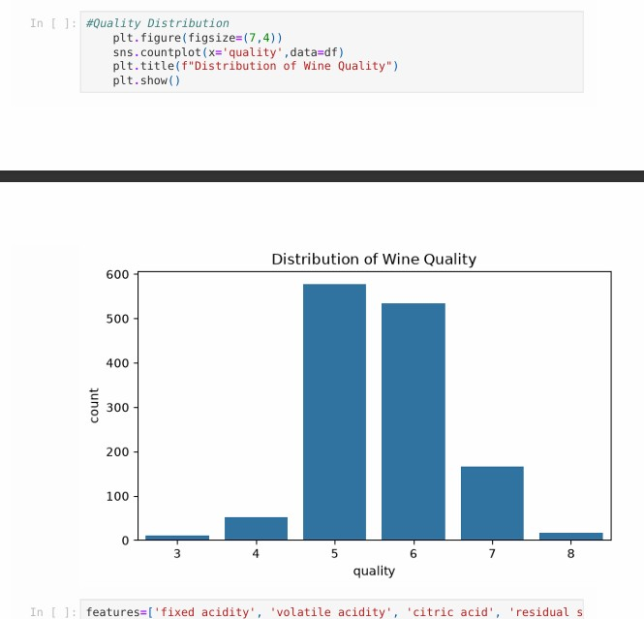• 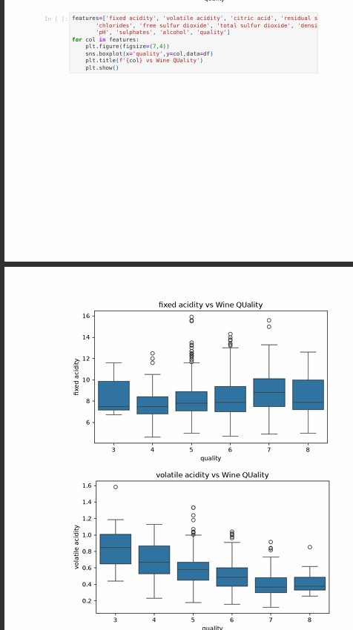• 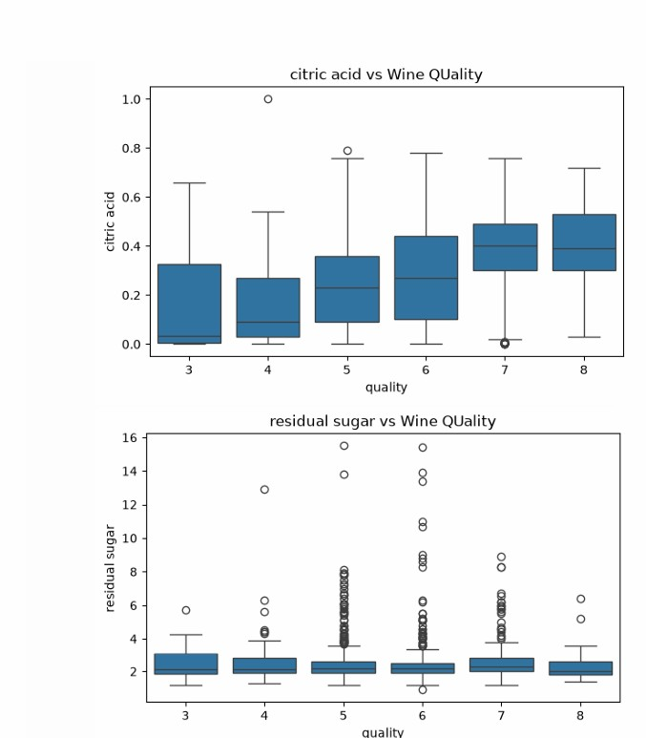• 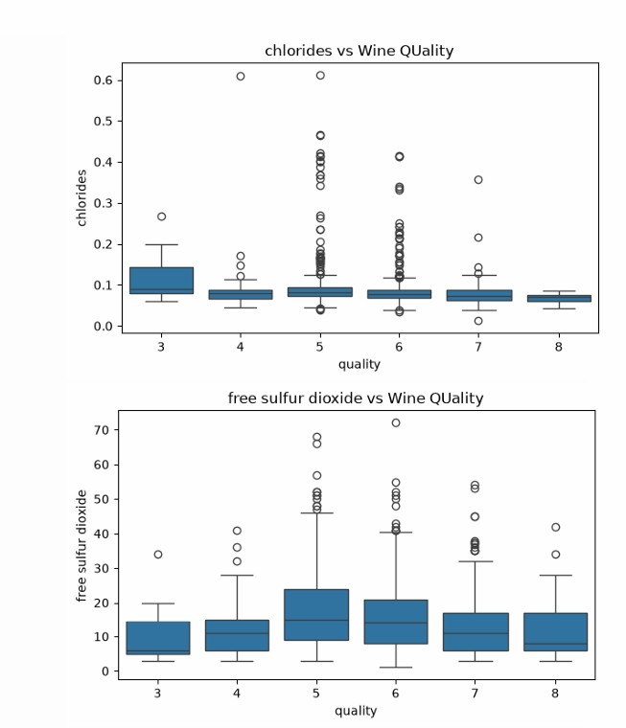• 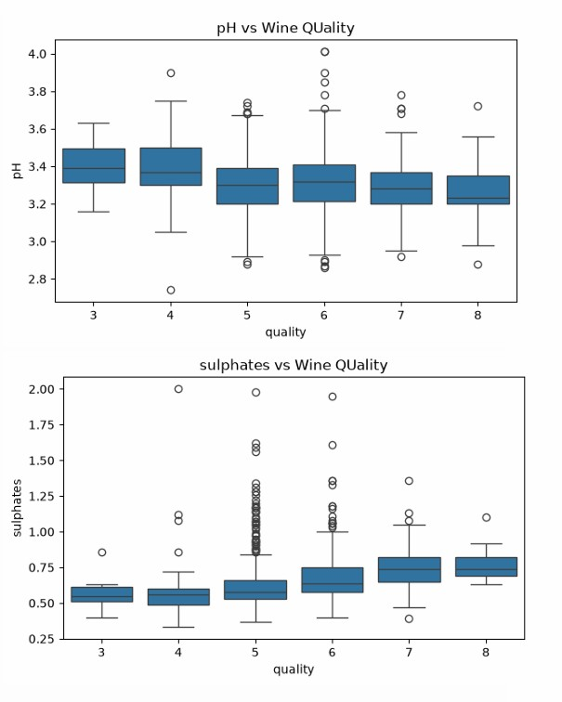• 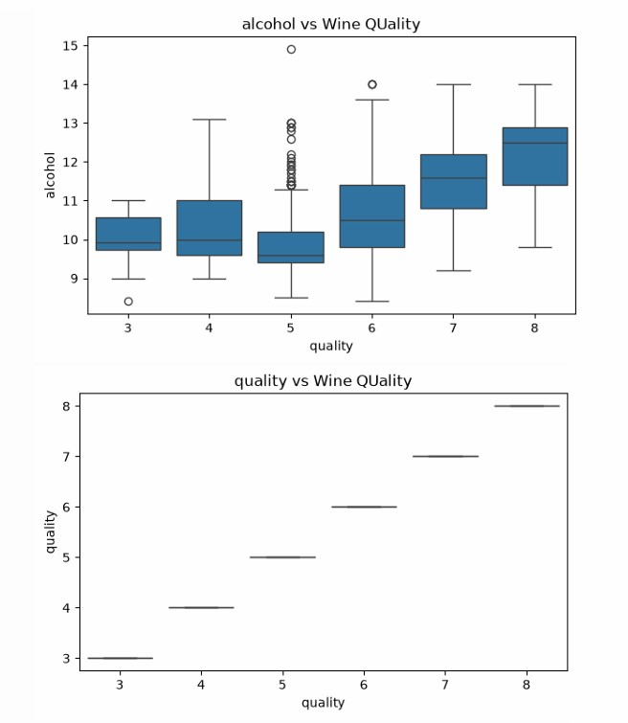• 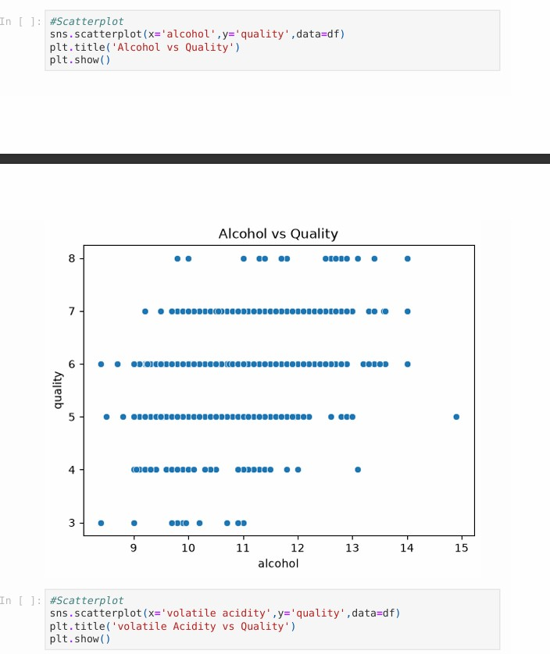
Definition: Multivariate analysis studies multiple variables together to understand their combined relationships.
- Core Idea: Focuses on interactions and correlations among variables, not just single-variable effects.
- Key Methods: PCA (dimension reduction), MANOVA (group differences), Factor Analysis (latent factors), Cluster Analysis (grouping).
- Applications: Widely used in psychology, medicine, economics, and machine learning for complex data insights.
- Challenges: High dimensionality, need for large datasets, and difficulty in interpreting reduced dimensions.
•
•
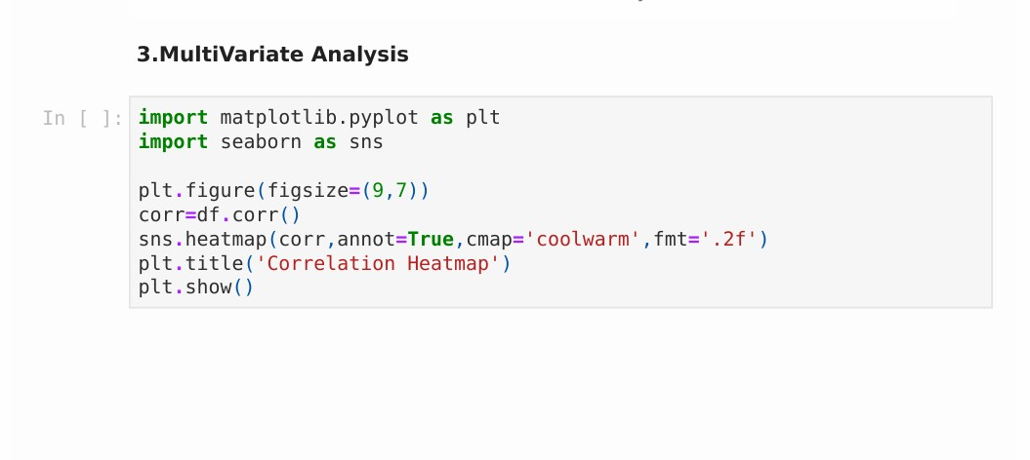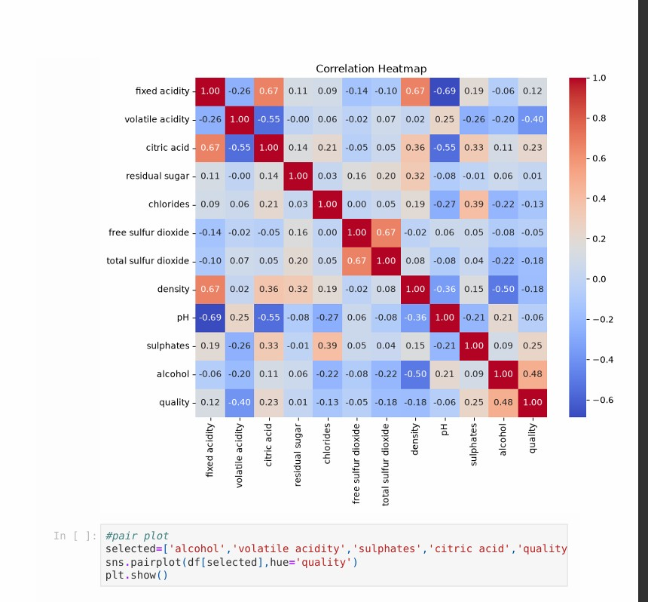
- 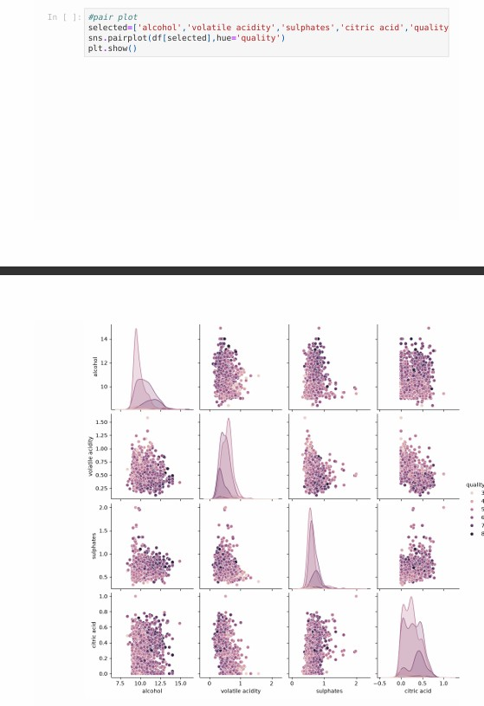• 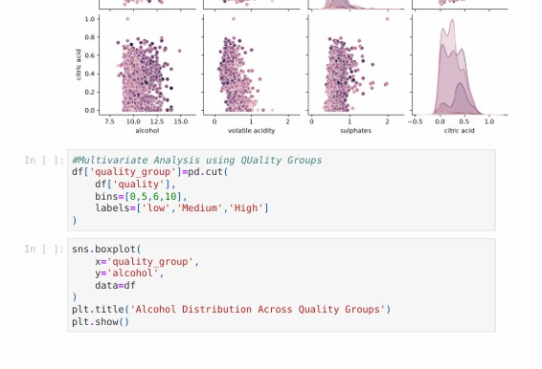
• 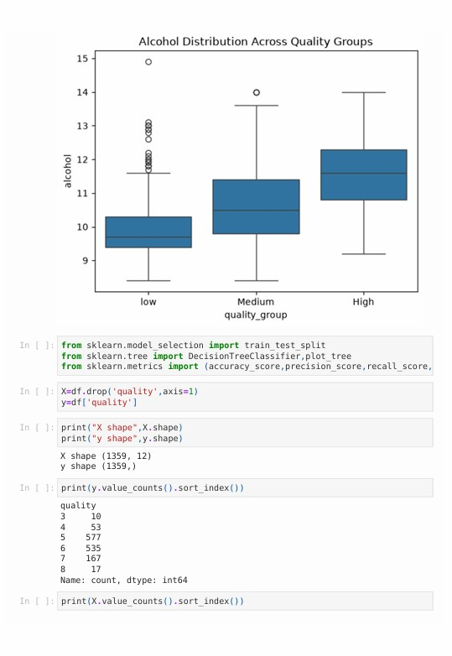
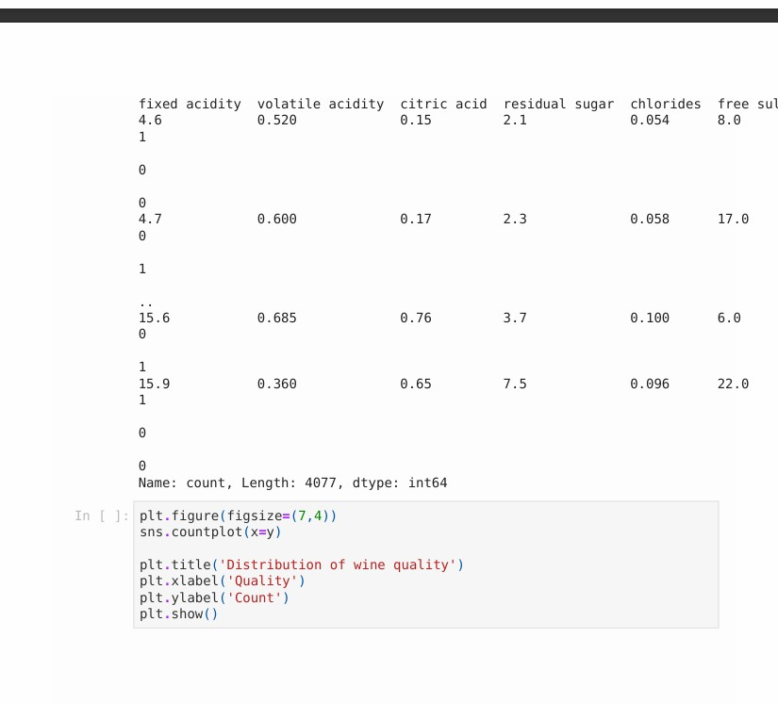
- 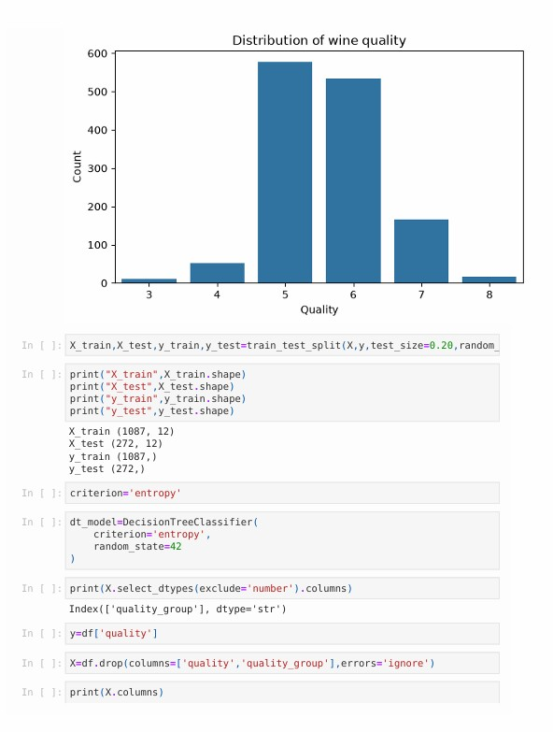• 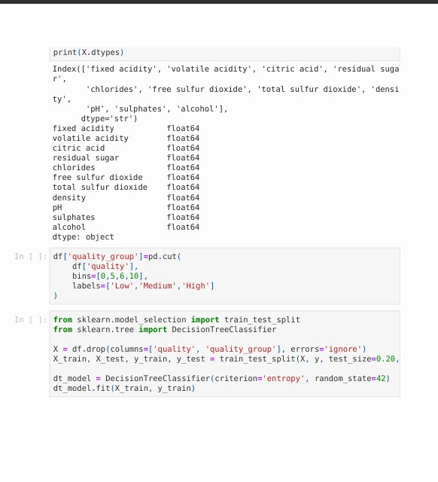
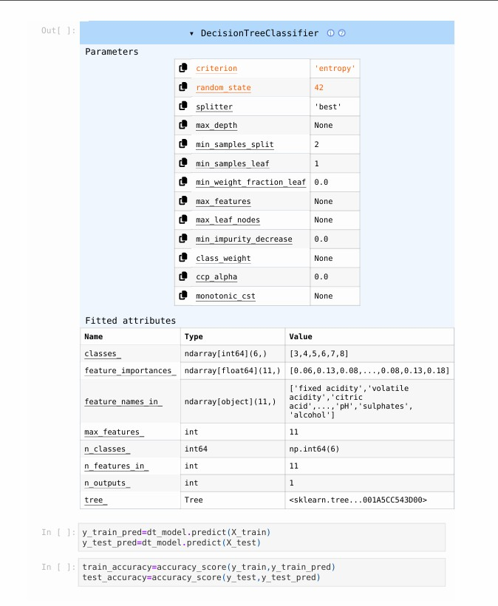

• Model Performance
• Theory: The Decision Tree achieved 100% training accuracy but only about 49.63% testing accuracy, indicating possible overfitting. Precision, recall and F1score are also calculated to evaluate classification performance.
•
• 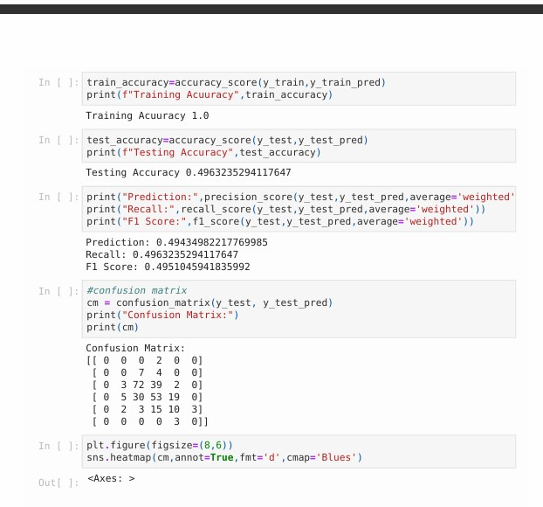
• 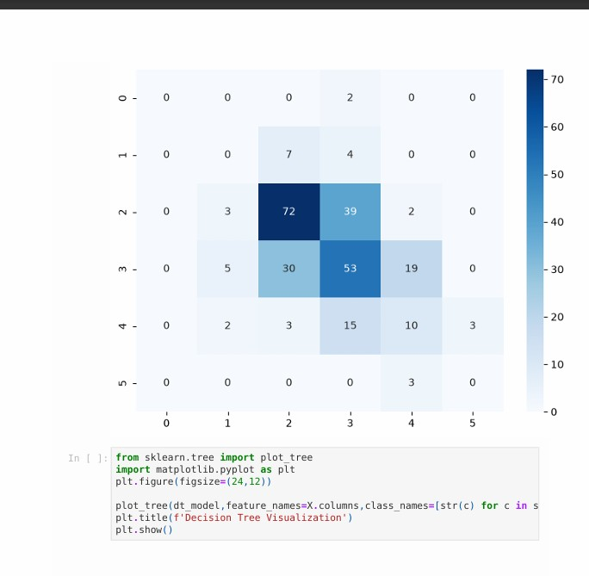

• Decision Tree Parameters
• Theory: The Decision Tree is configured with Entropy as its splitting criterion and random_state=42. These parameters control how the tree is constructed and make the experiment reproducible.
•

• Complete Decision Tree
• Theory: This visualization represents the complete Decision Tree Classifier, where features are used to split the data into different wine-quality classes. Each leaf node represents the final predicted class.

• Complete Decision Tree
• Theory: This visualization represents the complete Decision Tree Classifier, where features are used to split the data into different wine-quality classes. Each leaf node represents the final predicted class.

• Complete Decision Tree
- Theory: This visualization represents the complete Decision Tree Classifier, where features are used to split the data into different wine-quality classes. Each leaf node represents the final predicted class.
- 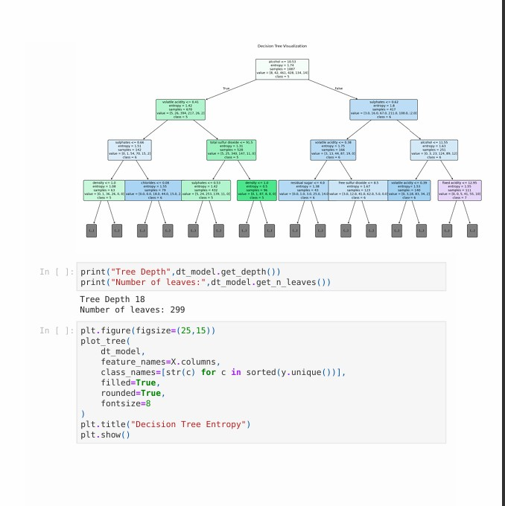• 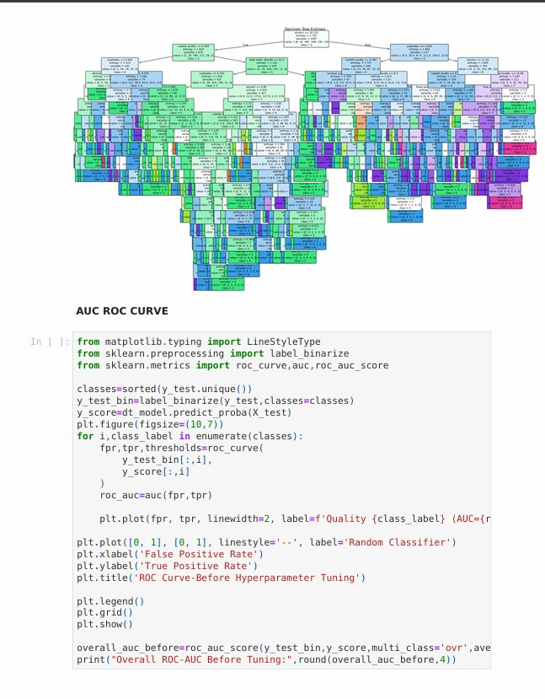

• Complete Decision Tree
• Theory: This visualization represents the complete Decision Tree Classifier, where features are used to split the data into different wine-quality classes. Each leaf node represents the final predicted class.
•
• 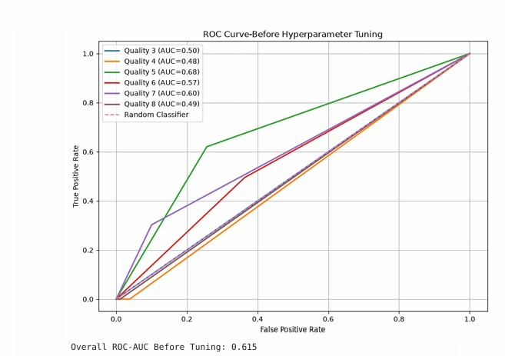

Viva Question and Answer
1. What is a Decision Tree?
Answer:
A Decision Tree is a supervised learning algorithm that has a tree-like structure. It contains decision nodes, branches and leaf nodes. At each decision node, the data is split based on a feature, and the final leaf represents the predicted class.
- What is entropy?
Answer:
Entropy is a measure of impurity or uncertainty in a dataset. If a node contains samples from many different classes, its entropy is high. If the samples mostly belong to one class, the entropy is low.
- What is overfitting?
Answer:
Overfitting occurs when a machine-learning model learns the training data too closely, including its specific patterns and noise, instead of learning general patterns. Such a model usually has very high training performance but lower testing performance.
- What is F1-score?
Answer:
F1-score is the harmonic mean of precision and recall. It provides a balanced measure when both precision and recall are important. The weighted F1-score in this experiment was approximately 0.4951.
- What is ROC-AUC?
Answer:
ROC stands for Receiver Operating Characteristic, and AUC means Area Under the Curve. ROC-AUC is used to evaluate the classification model's ability to distinguish between classes. A higher AUC generally represents better classification performance.

Conclusion
In this experiment, the Wine Quality dataset was successfully loaded, explored and preprocessed using Python libraries such as Pandas, NumPy, Seaborn, Matplotlib and Scikitlearn. The dataset initially contained 1599 records and 12 columns. No missing values were found, while 240 duplicate records were identified and removed.
Univariate, bivariate and multivariate analyses were performed using histograms, boxplots, scatterplots, correlation heatmaps and pair plots to understand the relationships between wine properties and quality. A Decision Tree Classifier using the entropy criterion was then trained to predict wine quality.
The model achieved 100% training accuracy but approximately 49.63% testing accuracy, indicating that the model was overfitting the training data. The weighted precision, recall and F1-score were approximately 0.494, 0.496 and 0.495 respectively. The overall ROC-AUC before hyperparameter tuning was 0.615.
Thus, the experiment demonstrated the complete process of data exploration, visualization, preprocessing, Decision Tree classification and model evaluation on the Wine Quality dataset.

